**CDAC Mumbai PG-DAC August 24**

**Assignment No- 4**

1. Write a program that demonstrates widening conversion from int to double and prints the result.

Solution:

public class Windning {

public static void main(String[] args) {

int intValue = 100; // Integer value

double doubleValue = intValue; // Widening conversion from int to double

System.out.println("Integer value: " + intValue);

System.out.println("Double value: " + doubleValue);

}

}

Output:



2) Create a program that demonstrates narrowing conversion from double to int and prints the result.

Solution:

public class Program2 {

public static void main(String[] args) {

// Declare a double variable

double doubleValue = 123.45;

// Perform narrowing conversion from double to int

int intValue = (int) doubleValue;

// Print the original double value and the converted int value

System.out.println("Original double value: " + doubleValue);

System.out.println("Converted int value: " + intValue);

}

}



1. Write a program that performs arithmetic operations involving different data types (int, double, float) and observes how Java handles widening conversions automatically.

Solution:

public class Program3 {

public static void main(String[] args) {

int intValue = 10;

double doubleValue = 5.5;

float floatValue = 3.3f;

double result1 = intValue + doubleValue; // int to double

float result2 = intValue + floatValue; // int to float

double result3 = floatValue + doubleValue; // float to double

System.out.println("Result of int + double: " + result1);

System.out.println("Result of int + float: " + result2);

System.out.println("Result of float + double: " + result3);

}

}

Output:

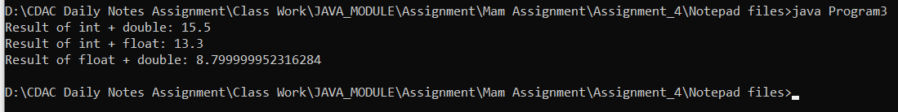

4) Write a Program that demonstrates widening conversion from int to (double,float, boolean, string) and prints the result.

Solution:

public class Program4{

public static void main(String[] args) {

int intValue = 42;

double doubleValue = intValue; // int to double

float floatValue = intValue; // int to float

String stringValue = Integer.toString(intValue); // int to String

boolean booleanValue = (intValue != 0); // int to boolean

System.out.println("Original int value: " + intValue);

System.out.println("Converted to double: " + doubleValue);

System.out.println("Converted to float: " + floatValue);

System.out.println("Converted to String: " + stringValue);

System.out.println("Converted to boolean: " + booleanValue);

}

}

Output:

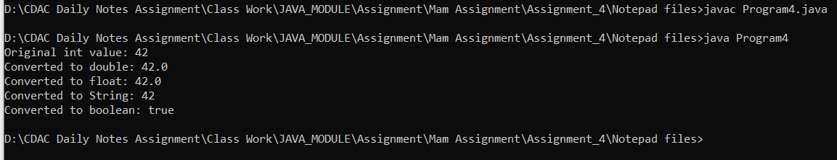

**Interview Questions**

**Note: Write down this interview question on your notebook ,Take a screenshort & Paste that SS in the word document & upload on your Github.**

**What does the static keyword mean in Java? Explain the difference between static and non-static methods.**

1. What is the role of the static keyword in the context of memory management.

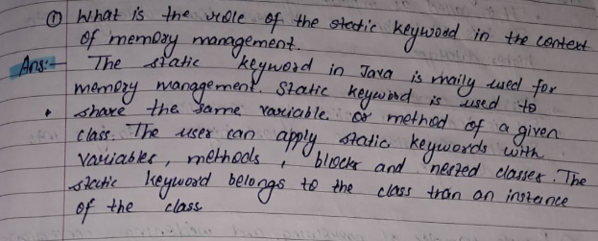

1. Can static methods be overloaded and overridden in Java?Howstatic variables shared across multiple instances of a class?

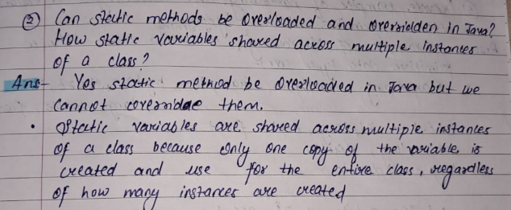

1. What is the significance of the final keyword in Java?

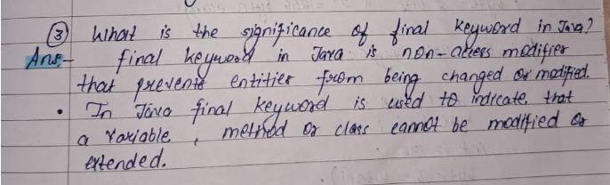

1. What are narrowing and widening conversions in Java?

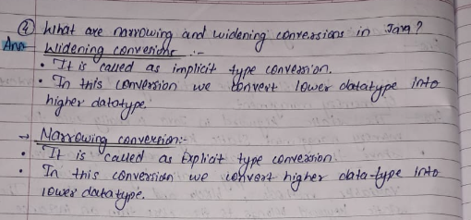

1. Provide examples of narrowing and widening conversions between primitive data types.

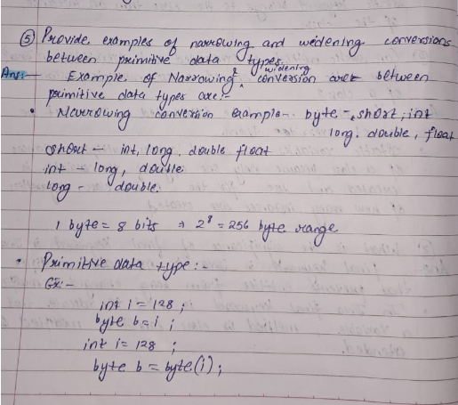

1. How does Java handle potential loss of precision during narrowing conversions?

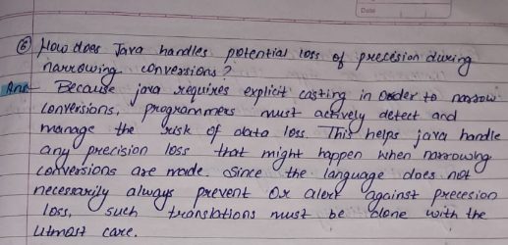

1. Explain the concept of automatic widening conversion in Java.

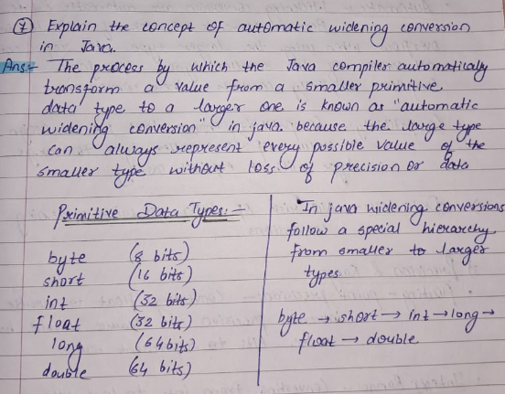

1. What are the implications of narrowing and widening conversions on type compatibility and data loss?

